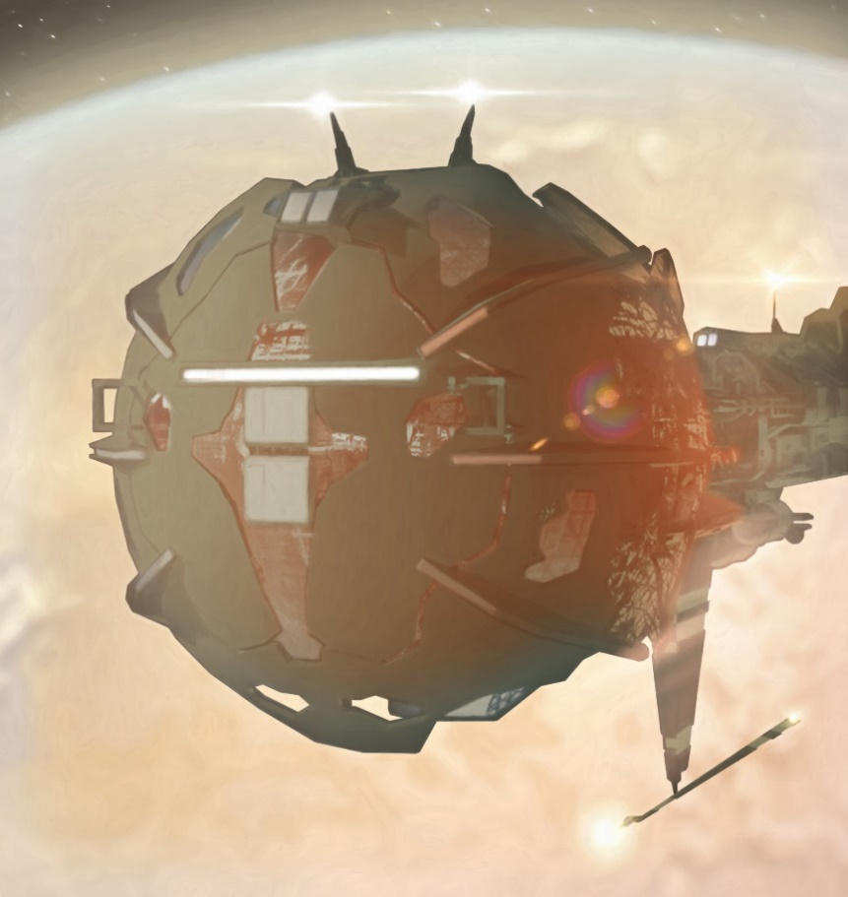

ThreeThree

Sutton belched; his thoughts overrode his belly; the first question answered: “Yes!”
The second question: Where might the ship transition?
The third question: How might the ship transition?
The fourth question: Would the crew enjoy another meal?
Sutton finished stuffing the Fat Burger remnants into his mouth and used a paper napkin he retrieved off the floor to wipe the grease from his beard. Too much mustard and condiments; his napkin was yellow/green. Bits of relish asserted themselves on the napkin.
The first question: Were they KnuckedHard?
Yes, certainly.
A brief moment of anxiety drew hand to facial hair. Rough skin met rougher fur. He might have to shave the beard, the chin follicles were a forest growth, and became an ever more pain in the anus to keep clean.
Perhaps he would alter his genes to stop the growth… should they all not become deenergized quanta in the near future.
Sutton had run ins with the potentially dangerous before; his first encounter with the KNAX came to mind. However, his crew had never been threatened directly or attacked prior to the current event. The KNAX had proved benign, if terrifying in their means and ways that far surpassed humanity. Fortunately for humanity the KNAX had virtually no interest in humanity as they dictated humanity had nothing to offer, other than disparate evolutionary tendencies in navigating their race’s future. Sutton was never more observant that the Exiters were much closer to that of the KNAX, and remained concerned that an alliance might be formed. What the Machine race considered important though was speculative mystery.
Sutton was a scientist not a military specialist.
Flicker flea fumes.
He belched uncomfortably. Though Sutton could have tailored a NeuralRelaxantFearInhibitor, he chose to embrace his rising anxiety and use that ProtoFear as a means to sharpen his reactions and thinking. Fear was a powerful ThoughtfulResonate when utilized correctly, and anxiety served.
Dead as dust was a looming potential.
Sutton sought the PD and maneuvered through the ThoughtPosits.
He uploaded: military tactics – Multigenerational Series, and AggregateDefense.
The data upload was extensive. His inner mind shuddered and adjusted cortical structure to assimilate the input. The steam was so intensive he directed the greater portion to his internal PD for reference and suggestion when topics were initialized.
What registered immediately was the importance of position in both defense and offense.
While The Fucking Office IV SpotWarped, Sutton reasoned there was no possible way to gain accurate readings as to what may have been about them or perhaps pursuing them. The strategy was to be ‘lost in space,’ and given the jumps after the attack, that’s what they had become - inadvertently.
Lost.
The Ship’s Lord knew only a true RelativeStop might let them recalibrate their actual position. To stop would intimate position, position was not to be intimated currently.
RelativityRules and BangExpansionPrincipals noted everything massive (or minute ) bobbing about the Universe was moving perpetually, relative to every other mass-object.
The number of calculations required to move from one star to another within a thousand light years was tricky. Trying to hit the stellar bullseye - when the target star was several million lightyears distant - required calculations that made ArtificialIntelligence whimper.
For always: the StarSystem one desired to visit was racing though space and influenced by other gravitational bodies about it - as well as shifting on its own personal SynodalVector within the rotation of the galaxy itself. So, in actuality one was warping or jumping to a potential location - which at best - was nearby the actual location one wanted, say a planet in the StarSystem desired.
Sutton and crew were deep outside the Hoag Galaxy and thus the typical references, such as pulsars and BurstEnergySources, were essentially located millions of years in the past, and thus, their locally perceived locations were quite different from their real time positions - if one was attempting to jump about inside a galaxy.
Given an observed stellar velocity for a ReferenceNavigationalObject was perfectly measured, one might calculate backwards in time to obtain a probable position the RNO might have been in, but again, given the gravitational perturbations experienced by all such objects… plotting an accurate destination point - first try - was still a probability statistic. Then, given the RNO’s best calculated position in RealTime, one could extrapolate a probable destination point, where one might not end up surprised or dead.
Long distance jumping and warping was often analogous to ancient sailing. Hop in a skiff on one side of the ocean, raise the sail and head for a port on the other side of the ocean - with only your eyes to navigate. Probability suggested you should make it across the ocean to the foreign shore, despite wind direction, currents, and human error on the tiller. However, once on the other side, one typically had to sail either up or down the cost make the true harbor one desired. This scenario was essentially an aspect of every fast space crossing… that humanity made.
Humanity was not the only entity in the universe that could jump and warp or use other faster than light modes.
Sutton knew an alien race that navigated better.
The machine race had been around a long time, thousands of galaxies turns longer than humanity had navigated the universe. The KNAX, however, could not be bothered to share their expertise. Council was rarely given, and audiences were seldom managed.
According to the machine race, The KNAX had little interest in biology and their missions - now that the MRs had evolved beyond that: “Primitive state.”
Humanity, allegedly, were also the newest species on the intelligence scene. So intimated Sutton’s sum-knowledge relegating the other alien characters inhabiting known space.
Why the universe was so devoid of intelligent life still seemed unfathomable to Sutton. DeepGalacticScrum and StarSystemSearch so far seemed to indicate: besides pond scum inventories, biologic signate searches and universal expository suggested more ‘nothing alive’ than ‘something alive’ occupied the greater universe. The Universe which humanity and its offshoots had studied.
Most HabitableWorlds were at best: bland biomes harboring microbes or festering swamps.
The past three thousand years revealed that with few exceptions most life in the MilkyWayGalaxy was found under water or in water, and that life rarely had even a primitive nervous system or reactionary biological analogue. The universe was mostly ignorant of itself - as intelligence seemed a rarity at the end of a biological bell-shaped curve.
In addition, what was associatively disconcerting was that the known alien races had almost no interest in Humanity, as if Humanity was also pond scum and best left to rot in its own mediocre swamp.
Except humanity had managed to leave their local ponds behind and were now exploring the greater ocean’s depth. Probability also suggested that much like the ocean only the surface stood out in the light that penetrated the surface. The better part of the universe was a dark deep that remained unknown. Other aliens might be hidden both away and deep in time.
Then again, humanity had brachiated into so many superspecies, the Personates and other rogue humanity constructs might be thought of as aliens, comparatively.
Thus, the attack might have come from an entity or alien unknown, or perhaps known and new. The number of attackers was finite nonetheless, and the attack had been made with known theoretical technology.
Given the rapidity and accuracy of the attack, the mystery entity which had disintegrated part of their ship was potentially a more advanced race, and perhaps fitted with technological advantages – abilities which might reveal The Fucking Office IV’s location.
Unknown.
Lord Sutton took-up the patty spatula and banged the bright shiny tringle that hovered over the grill.
Most gave the SurveyTeamLeader their attention.
The LastCrew appeared to have finished; some had eaten, others sported leftovers or fully uneaten meals – the soggy buns slumping in their bright red plastic baskets. A few sucked on their straws, finishing off their fountain sodas.
“Ok, while I was playing short order chef, I also managed to put together a DataFile outlining current events. I see that most of you have shared. Those who have not, please join my InfoCoreNode.”
Sutton tossed the spatula back on the grill with a clatter, he continued.
“Right. Review. A fifth of our ship is missing, causes unknown. Thirteen of our crew are eliminated, and Fat Burger shall remain closed till further notice as we are all out of special relish as it’s now in deep space.”
A few grinned, breaking the tension. The Restaurant remained mute, only the idling grill made any return; a few sizzles - burning the remaining meat crumbs and onion rings - browner or black.
“Any thoughts? Please WordSpeak your postulates.”
The LastCrew’s other Caskoid, Caltalungimnimenumbungta, raised two of her hands. She proved second engineer title, and basically kept the ship running.
“Yes, Calta.”
“Calta, Calta. Inputs.”
“Sorry. Calta, Calta. Proceed please.”
The ‘Calta Calta’ introduction pleasantries enacting reply, since she was the second Caskoid to interject. As clones they all tended to look alike out of their clothing. All Caskoids used the pre-moniker Calta. Their names were typically long and tongue-twisters. ‘Calta’ was simply easier and accepted. Though, when two or more Caskoids were together in the same room, Sutton left the HeavyWorlders to sort out ‘to whom he was speaking.’
“I think we were reactioned by an ExiterBeam. The damage seems to indicate total molecular division, instantaneously. I have composed an InfoNode explanation and analysis. Please access.”
Sutton uploaded her IN flow and incorporated the data into his background consciousness for later pursual.
He retorted, “A HazardCyc. My studies also seem to indicate a BeyondEnergy discharge similar in effect to Exiter technology. However, the DischargeEffective was of a power never before witnessed… that I am aware of. Thus, follows the question, why are Exiters in the Hoag system? They have never been recorded here before, and Hoag seem oblivious to their existence.”
A tiny arm made its way above an oversized head.
Next upon StageVerbiage was Chingchan, a TruePerson from Xi - one of the first PersonColonyWorlds settled during the first HumanWave colonizations; galactic planetary colonization initiated a couple of thousand years ago.
Xi had been discovered by another great telescope, the ancient but formidable James Webb Telescope. One of Sutton’s favorite ancient telescopes - the tool that had accurately begun to image the universe and had laid a pathway for extrasolar exploration in distant ancient times, when humanity was still isolated on a single planet.
At that time Xi was just another moon about the massive gas giant that quickly circled a low luminosity white dwarf sun; the lesser sun in a binary star system featuring a main sequence white star – dully-charted and labeled: WS1237-224B. The white dwarf had been overlooked until the James Webb began a secondary survey of the local suns within 10,000 light years.
Xi was a SuperHeavyMoon orbiting a gas giant - in a star system within the blackout zone. A white star located about 2000 lightyears distant from HomeWorld.
A planet well praised amongst the PanPersonPlanetaryUnion.
The TruePersons inhabiting Xi were a proud race which had originated in AncientChinaAsia. Sutton respected the race as they were more original than just about any other PersonateColony in the MilkyWay.
Chingchan was an unusual character - in respect to the average constituency that composed the LastCrew. Chingchan was undeniably the shortest crewmember, not even a meter tall, and skin so yellow that a daisy’s center would be jealous. Chingchan was also Sutton’s TopMind when dissecting alien relations and technologies. The Xian was so dedicated to his life studies that after his accidental death, Chingchan had been RequestReborn and re-assumed his position with the Sutton SurveyTeam.
His opinion was typically weighty, and he liked to transfer knowledge using his own vocal cords. Chingchan’s race still spoke MultiSpeak as commoner’s tongue, Sutton’s language of choice. Probably why Chingchan was invited to Sutton’s KeyQuarters often - for word games and scrum.
Most of the Personates on board The Fucking Office IV spoke a gunshot-language of their own - unless caught-up in the company of the multi-raced LastCrew. Then, MultiSpeak was the common denominator.
VerigatedPersonates typically conversed via implant, and refrained from vocalizations, which Sutton found annoying at times. He had enough voices and thoughts in his head.
Many Personate InfoCore languages were primarily mathematical descriptions in brief formula – Sutton’s favorite FormulaicExpression being the notation for sex - which was: π
Math was a fine language, but not friendly to the human natural cortex without specific neural enhancement or PD extension.
Humanity had evolved to speak, and part of that evolution allowed verbal considerations - as the words made their way out of the skull. Composing replies involved thinking and thinking using the inner voice was a mode that often derived the best answers and decisions – in Sutton’s opinion.
Machines and AI were advantageous when automation was required, yet the machines that humanity had constructed still lacked the ability to render unprogrammed associative creatives. The biochemical computer inside his cranium was the problem-solving method Sutton preferred. Think first; run the thoughts through a PD or AI for analysis.
The LastCrew acquiesced to his ancient standards, though Sutton was sure that his ancient ways annoyed the Genetically Enhanced. No rumblings ever took place, but another’s face could not always suppress a disgruntled wrinkle.
Softly, carefully, Chingchan vocalized, “Lord, Sutton. If I might offer this information. We know of five intelligent races in the universe at large. Humanity, including the Exiters, Hoag, The KNAX, Server, the GAAS… and perhaps another sentient race at TheWall, probably long extinct, but that is secondhand information and not confirmed. We must speculate that one of these races produced the effect that damaged our ship. The Exiters have made it known that they wish to eradicate humanity. Only efforts made by the 43PersonateSquad in tandem with Server’s actions have been able to keep the Exiters quarantined in Andromeda. Server appears to have vanished. Thus, our current destructive causative may be the works of the Exiters, but perhaps not.”

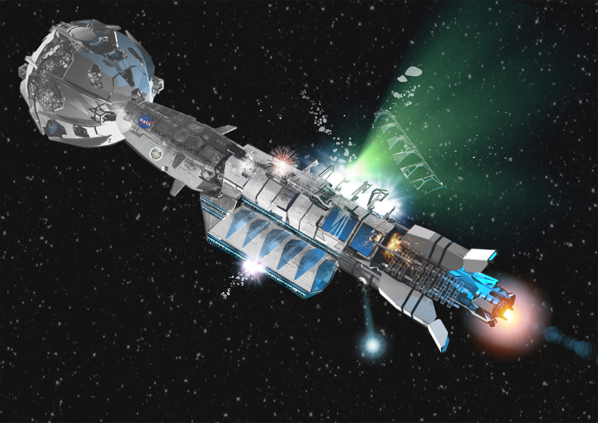

“Potentials. Continue.” Said Sutton.
“The Exiters may have broken out of Andromeda by developing technology that has eliminated or compromised Server. However, we think that our mission was uncompromised before departure. So, how the Exiters would know we are here is practically impossible, unless we were followed when we departed, and if so, by whom? Is there an Exiter amongst us?”
“What we are here for.” Sutton seemed unphased.
“We have been forbidden to access this space by Hoag. Our Hoag studies note they are not a faster than light species. Yet the works in their galaxy seem to be of a power that we have not witnessed to date. Though Hoag live an extended lifespan in the hundreds of millions of years, we are now beginning to conclude that the rearrangement of their galaxy may not have been produced by Hoag. Hoag claim the Galaxy’s re-formation was accomplished by their race, but perhaps this is not the case. I add this postulate as speculation, perhaps there is a reason that this area of space is forbidden. Perhaps we have discovered that reason. The reason may be that this space is being monitored, and if this space is monitored, perhaps there is another race we do not know about securing this area. My speculation has always been discounted, but I believe that another race constructed HoagGalaxy. Perhaps the race that produced Server. Hoag are aware of Server and Server of Hoag. Yet, the PureElectric and Hoag seem never to interact, that we know of. What are Hoag really? What else resides inside their galaxy that we have yet to encounter?”
“That is what we have been on about for more than 300 years, and we are no closer to understanding that question.”
“Thank you for your attention, Lord Sutton.”
“Thank you, Chingchan. Next?”
The next set of hands in the air belonged to Strombii. Sutton had been waiting for the she/she to input.
“Yes, Strombii.”
“Chingchan stands squat. I think he SpeculatesPossible. The warp wake I have analyzed is not of any known craft. The displacement wake does not belong to any known race. The wake signature indicated a probability that the MassMoved exceeded a million times greater than The Fucking Office IV. An entity massing moon quantity. Our knowledge on Exiter technological enhancement is limited. However, they are mostly AI-Life Negative now, we think. The attack was astute and immediate. The attack was targeted from a distance, and our position was known to the attackers, who seemed to have intimate knowledge of our location.
Strombii paused, and her face went cold…
“Regardless, current events suggest we are not welcome here, at the cost of total disintegration. My suggestion is KnuckAway. Now.”
“I agree,” said Sutton, “and after what has transpired, we need to get to a safe port. Seems we have irritated some very powerful folk. I’m not sure though where that safe port might be. I have been turning options over in my mind, and I think I have the best answer. Any thoughts on where you crew think we might go?”
A few hands raised above heads; StarZure, Gib; NEco.
StarZure, “Planet Clair.”
Gib, “HomeWorld.
NEco, “An alternate Universe. I don’t know if we are safe in this one. QuickQuick.”
Sutton twist-tugged on his beard.
He snorted and let out a few choice assumptives, “Planet Clair might be a good regroup position, another galaxy in the local group might be secure, given circumstances. Triangulum… that’s a jump and a jump and a jump. Yes, jumping far might give us many orbits for disassociation. But… I’m not measured for running-far just yet.”
He moved his eyes focus towards Gib.
Two of Gib’s four eyes were locked on Sutton’s face. The other two seemed closed in contemplative thought.
“Gib, I would not choose HomeWorld presently. We know HomeWorld is in black out, and nothing that goes into SolSystem comes out, allegedly. I’d like to go home also but being homesick cannot mediate our situation. HomeWorld has less to offer in protection than other personate worlds in the local group of galaxies. Sorry, not an option currently. Do we want to drag our problems back with us to conflict our extended family?”
NEco was smiling. He always did. Hard to get a straight answer out the xenobiologist and artist.
“Good addition, NEco. OutUniverse might be the safest place,” Sutton chuckled, “thanks for your input.”
“Certainly, Lord. Blink blink out.”
“Crew, I’d like to spit my get the heck down the road option by you. The ship is damaged. We can only warp about. Whatever smacked us is likely still out there. I agree we need to move fast, and away from here. Here is what I’m thinking. A bit of piracy and trade… if that maneuver is possible.”
“Piracy? Who we going to board? YARRR AND HOLD!” From Neco, he was giggling outlandishly and waved an invisible sword in his hand.
Sutton could not help but cast a smile; even given the ships traversing the universe’s gleanings and evolution, piracy still existed. A Viking ship on the black north seas traversed his imaginationings.
“Hoag FocusPlatforms always assume additional satellite mass, closely orbiting their stations. Given additional raw mass we can not only fix the ship but build a secondary fast drive. The closest FocusPlatform that we know of is number 345. One would assume given the great distance from HoagGalaxy that 345 should harbor substantial additional mass. Mass we can barter for and replace at a future time. We can site an emergency, which is true. Hoag may have extra mass to barter, and perhaps going there will give us a heads-up on current events. If we try to warp directly back, we will produce a warp signature down the focus line, should we take the direct route. I suspect that route will be monitored by our blast-happy FocusLine guardians. Warping indirectly in flicker might mean a longtime journey, orbits in the tens. I don’t want to be a zombie when we are targeted again and disassembled into quantum foam. We need to move faster.”
Sutton let that thought settle on the LastCrew.
Strombii spoke out, “AccelerationDrives are forbidden. Using an AD is against HumanityTreaty and HoagTreaty. We would probably end TheTransition dead. Additionally, wherever we DriveEmerged might potentially destroy an entire solar system. If what ravaged our ship follows us to 345, won’t that put Hoag in jeopardy?”
“I don’t think we have a choice. We might note that as far as we can ascertain Hoag are not in Jeopardy. Hoag might in actuality be the cause of our situation. Also, a risk in approaching Hoag for assistance. We need to move and to move fast. Accessing AccelerationSpace is the only way to get the knuck out of this universe while we move as fast as we know how, as NEco has subtly intimated.”
The crew’s other Caskoid jumped in.
Caltapostlumineminggentoolimlinum’s comment was hard and potent, “Calta, Calta, Calta. Building an AcclerationDrive and fixing the ship would consume a few StandardTimeUnits minimum. We would also need several thousand MassMegaUnits to affect rebuild as well as cannibalizing the ship for every bit of high-atomic-number atoms for ShipsCreator to FabraPrint and install an AccelerationDrive. Drive fabrication would likely mean we would have to transmute the WarpDive into components for the AD. Considerables? Even if we do obtain additional mass, we sit ultimately vulnerable while components are built and situated. Additionally, we will then have no WarpDrive.”
“Yes and no. Depends on how much mass we can acquire. We can also pull energy from the vacuum and transmute that into matter, while we sit. That will speed up the process. I would not compromise the WarpDrive. We would fabricate an Acceleration Drive from external masses bartered or generated.”
A voice followed. A high-pitched voice that was analogues to a person who had breathed in helium.
Concho; the ship’s MasterNanoChemist.
The NeuterBeing had joined the crew only an orbit before. The folks on Planet Zing had decided to send a contingent of volunteers to assist the SuttonSurveyTeam. Concho had been the brightest by far and Sutton had conscripted Concho in the ship’s cantina at first meeting. The NeuterBeing had actually decoded a portion of one Hoag codexii. An ability that had superseded the re-AI’s decoding formulaics. Data and chemicals that the team had input in the hopes of breaking and processing the billion-bit DataW0raps. TheFolks on Zing typically had two brains stuffed in an overly large skull. Zing flaunted three brains in its NeuterBeing’s skull, a head which had an additional bulge in back to accommodate the third cortex.
“Will Zippy recover?”
The subject ChangeCracked Sutton’s gut. He slumped.
“Thank you, Concho. Please join the medical feed for updates, but she is still coma-induced, and she is being re-built as we speak. She will survive.”
Sutton Paused. He surveyed the survivors, considering his feelings.
He was not a sterile machine, even given his LogicEnhancements. Being humanish was preeminent. A pause ensued the room. Even Personates retained primordial feelings.
Finally, his lips parted, “We have lost so many. We will be having a ReClone commorancy ceremony as soon as time permits. I’m so sorry that harm has come to our LastCrew. We retain and FreshStore their memories and cells, so they shall return eventually. Eleven of the thirteen were backed up with a secondary brain. Unfortunately, KO’M’bi and KE’M’bi are ForeverDead.”
The forever-deaders were bunk mates and partners; OrigianlPersons who did not practice uploading LifeMemory or secondary brain backup. They claimed life-experience was to live once - naturally.
They received their wish.
Sutton detached. He switched off his InfoCore, lest his ThoughtDrift and be ascattered by his compatriots. Thoughts he wanted in his own cortex solo.
What was the reason the LastCrew had joined the SuttonSurveyTeam?
Why were any of them here?
What was contemporary motivation?
Once woken into the Universe and old enough to understand the Universe, one had to make decisions or not - if survival was warranted. The natural human push to survive was what allowed evolution to counter chaos.
What were the true reasons that any of humanity did anything they had done?
Was there a grand universal plan unbeknownst to all that suffered consciousness?
Was universal evolution just a deck of cards shuffled blindly and delt a joker at a time?
Whatever the deck deal… would chaos always eventually wins the consciousness survivability game.
Could those delt underwhelming existence become the dealer?
Sutton switched nodes, “Waldo, how long to Focus Platform 345?”
“Approximately three standard rotations, fast as we can go.”
“LastCrew. FuelBurn cortex time. We may have made privy to a circumstance about ancient HomeWorld that others find sensitive. Sensitive enough to eliminate us. Hoag ships visited HomeWorld in the ancient past and left. Why Hoag went to AncientEarth, and which Hoag race accomplished that journey is still an unknown. One has to ask, why would Hoag bother with AncientEarth 600 million years ago? Who is currently offended should we retain knowledge of this occurrence? And the ultimate question… if this is such an important position in space, why did Hoag not have a FocusPlatform nearby? What factors obviate obliteration?”
The stagnant faces about him were silent. Thoughtful and mute.
The Lord rambled on, “Murder and malice have tweaked our direction; flipped our mission. Prudence suggests avoiding conflict. Killing our crew has modified a run and hide stance. Should we be content with ignorance and death? Posits?”
Sutton flinched; a cumulative InfoWave deposited a ThickCore inside his head; the LastCrew’s unanimous reply; mathematics danced and wove - the formula known as [F] = [U].
“FineFine, shall we ZipFrop and ask Hoag a few questions? I don’t feel we have much more to lose or gain at this stamp. Besides, it has been a while since we played a good game of poker. Waldo, blast, and bounce!”
“Actuating, Lord.”
As the LastCrew rose from their tables, the ship shivered.
Sutton hoped that the broken tub might hold together long enough to attempt repairs.
Sutton droned a sighing expulsion he had not felt in centuries. Deep loss.
He took off his cooking apron, folded it, and set the garment on the counter.
Without noting his own movements, and subconsciously avoiding those still seated in the restaurant, shuffling about on internal autopilot, he pushed though Fat Burger’s double entry doors and made way to the infirmary… to personally connect with Zippy.
Sutton understood at that moment why at times working as a short order cook was superior to being a ships’ Capitan.

